

Welcome Hubs

Conversation

Kit

Who are we? We are a group of people interested in welcoming people into our communities with a focus on new arrivals.

What do we do? We help people to connect with each other and to the community through welcome conversations.

Why do we do it? To help people link into their local community, find their feet and the words to do it.

How do we do it? Through easy English conversation classes, introducing people to each other and their community. By providing a place for people to connect and build relationships through conversation, community outings, events, meals and friendship.

How to use the Kit? You are welcome to add/adapt/copy this Welcome Hub Conversation Kit for your group. This kit was developed by Kim Hood and Judy Salecich and the West End Welcomes Team. Contact information for this Kit: Kim Hood: [ozenglishcorner@gmail.com](mailto:ozenglishcorner@gmail.com). Or for the West Welcomes Hub: Jenny Geale: westendwelcomes@gmail.com

**Overview**

Welcome Hubs arose out of a desire to respond to new arrivals in our local communities. The new arrivals being people seeking asylum. Asylum seekers have unique language needs. They need language that will help them to connect and survive in their local communities, connect with local services and local people in order to find accommodation and work (paid or volunteer - visa permitting).

In light of their needs, welcome hubs are designed to provide the relationships and words new arrivals need for daily living. Words for communication, not grammar lessons. Words that are used in relating to locals, not text books or worksheets. Words that promote understanding, hope and a sense of belonging.

In this kit you will find 8 welcome conversations with resources. Each conversation covers a topic that interests new arrivals. They are designed for each local community to add/adapt and provide pictures suitable for their group of new arrivals.

**Format**

***A suggested format:***

1. Tables in café style format. With a conversation partner/teacher and new arrival/s at each table. Conversation menus and resources placed at each table.

2. Large group welcome warm up/introduction

3. Small group conversations with changing pair work:

a. You can do one conversation topic each week

b. You can have a conversation ‘buffet’ where the small group decide which topic they would like to cover.

c. For continuing students who have completed all 8 topics can be invited to be facilitators for other new arrivals.

4. Large group summary/quiz/ information

5. Shared meal or invitations to conversation partners’ homes for dinner if possible or at least once during the cycle.

**Welcome English Class 8 Week Cycle**

|  |  |  |
| --- | --- | --- |
| **Week** | **Topic** | **Resources** |
| 1. About us | Who am I? Where do I come from? Where do I live? What do I do? | * Introductions – Hello in own language and English * Map of the world (and country if you know where the arrivals come from – Sri Lanka, Afghanistan, Burma, Iran, Iraq, Syria for example * What I do each day – appointments, meeting people? Blank weekly schedule for arrivals to complete and discuss |
| 2. About where we live | Things to see and do in the local area | * Map of Australia * Mud map of local area – main streets – can use electrical tape on tables for streets * Pictures/names of free or cheap places to eat, shop, visit to place on map * Computer access * Parks * Cheap transport options * Worship centres- church/mosques/temples |
| 3. About our country | Describing home town and comparing with current location | * Map of world * Map of country * Map of Australia |
| 4. About our work | Past work  Survival work  Future dream work  Talking in the interview | * Job interview questions * Resume example |
| 5. About our accommodation | Describing previous accommodation  Current accommodation  Future housing needs | * Pictures of types of housing – house, apartment, backpacker, hostel * Local rental ads/ads on internet sites * Where to find cheap furniture * Map of local area or city * Public transport availability * [Video Link](http://www.youtube.com/watch?feature=player_embedded&v=smdbnTfpKpw#!) for renting in Australia for new arrivals – You Tube: Asian orientation information - Housing and Safety – immTV – www.immi.gov.au   For copies of ‘Australia – a new home’’, ask your settlement service provider, email  DVD.Requests@immi.gov.au or contact the Department of Immigration and Citizenship office in your state or territory. The DVD chapters are also available in English on IMMI TV, see  www.youtube.com/user/ImmiTV |
| 6.About our food | Popular Australian food  Easy recipes | * Tasting different Australian foods – vegemite, Anzac biscuits, lamingtons * Easy recipes – Anzac biscuits, chicken pie |
| 6. About our interests - sport | Celebrities from my country and Australia and my interests | * Pictures of famous people from the new arrival’s countries – sports players, actor/actresses etc |
| 7. About our learning English and volunteering | English classes available  TAFE classes  Volunteering opportunities  Keeping Busy | * Free English class list * TAFE class information * Volunteering information: Go Volunteer [www.govolunteer.com.au](http://www.govolunteer.com.au), Volunteering Australia [www.volunteeringaustralia.org](http://www.volunteeringaustralia.org); Australian VolunteerSearch www.regionalaustralia.gov.au * Blank weekly timetable * Map of city |

**Resources:**

**Beginning Life in Australia**. The Beginning a Life in Australia booklet is produced by the Department of Immigration and Citizenship

(DIAC) and is published online at [www.immi.gov.au/living-in-australia/settle-in-australia/beginning-life](http://www.immi.gov.au/living-in-australia/settle-in-australia/beginning-life). It is recommended that you view the booklet on a computer as it contains links to many websites that provide additional information. The booklet is reviewed and released annually and is available in PDF format.

**Church and Community English classes in Australia:** Go to [www.yourenglishcorner.net](http://www.yourenglishcorner.net)

**National Directory of Asylum Seeker and Refugee Service Providers.**  Compiled and updated by the ASRC Campaign Team December 2012 – see <http://www.asrc.org.au/media/documents/asrc-resource-directory__.pdf>

**Asylum Seeker Resource Centre**: <http://www.asrc.org.au/> . The Asylum Seeker Resource Centre is one of Australia’s leading asylum seeker organisations. They are a multi-award winning, independent and non-federal government funded human rights organisation. They work at the coalface assisting some of the most disadvantaged people in our community.

**Multicultural Development Association: MDA** - http://www.mdainc.org.au/

**Red Cross Migration Support**: http://www.redcross.org.au/migration-support.aspx

****

**Conversation Menu**

**About Us - Introductions**

**1. Introductions**

**A**: Hi. I’m \_\_\_\_\_\_\_\_\_\_\_\_\_\_\_\_\_\_\_\_\_\_ (name). What’s your name?

**B**: Hi. My name’s \_\_\_\_\_\_\_\_\_\_\_\_\_\_\_\_\_\_\_\_. Where do you come from? (name of city and/or country).

**A**: I come from \_\_\_\_\_\_\_\_\_\_\_\_\_\_\_\_ (city) in \_\_\_\_\_\_\_\_\_\_\_\_\_\_\_\_\_\_\_\_\_ (country). Where do you come from?

**B**: I come from \_\_\_\_\_\_\_\_\_\_\_\_\_\_,(city) in \_\_\_\_\_\_\_\_\_\_\_\_\_\_ (country). How long have you been here?

**A**: I’ve been here for \_\_\_\_\_\_\_\_\_\_\_\_\_\_\_\_\_\_\_ (number of weeks, months, years). What about you? How long have you been here?

**B:** I’ve been here for \_\_\_\_\_\_\_\_\_\_\_\_\_\_\_. What are you doing in \_\_\_\_\_\_\_\_\_\_\_\_\_\_\_ (city)?

**A**: I’m looking for work. What about you? What are you doing?

**B:** I’m looking for accommodation

**A**: What did you do in your country?

**B**: I worked/work as a \_\_\_\_\_\_\_\_\_\_\_\_\_.

**A**: Do you like Australia?

**B:** Yes I like……. (the weather, the people, the food). How about you?

**A**: I like the clean air. Oh I have to go. Nice talking with you.

**B**: Yeah nice talking with you too. All the best.

## **Vocabulary - Useful Expressions Greetings:** Hello, G’day, Hi

**ASK:** a. How are you? b. What’s up? C. How’s it going? What have you been up to?

**Answer:** a. Good thanks. b. Great. c. Nothing much

****

**Conversation Menu**

**About Us - Introductions**

**1. Introductions**

**A**: Hi. I’m \_\_\_\_\_\_\_\_\_\_\_\_\_\_\_\_\_\_\_\_\_\_ (name). What’s your name?

**B**: Hi. My name’s \_\_\_\_\_\_\_\_\_\_\_\_\_\_\_\_\_\_\_\_. Where do you come from? (name of city and/or country).

**A**: I come from \_\_\_\_\_\_\_\_\_\_\_\_\_\_\_\_ (city) in \_\_\_\_\_\_\_\_\_\_\_\_\_\_\_\_\_\_\_\_\_ (country). Where do you come from?

**B**: I come from \_\_\_\_\_\_\_\_\_\_\_\_\_\_,(city) in \_\_\_\_\_\_\_\_\_\_\_\_\_\_ (country). How long have you been here?

**A**: I’ve been here for \_\_\_\_\_\_\_\_\_\_\_\_\_\_\_\_\_\_\_ (number of weeks, months, years). What about you? How long have you been here?

**B:** I’ve been here for \_\_\_\_\_\_\_\_\_\_\_\_\_\_\_. What are you doing in \_\_\_\_\_\_\_\_\_\_\_\_\_\_\_ (city)?

**A**: I’m looking for work. What about you? What are you doing?

**B:** I’m looking for accommodation

**A**: What did you do in your country?

**B**: I worked/work as a \_\_\_\_\_\_\_\_\_\_\_\_\_.

**A**: Do you like Australia?

**B:** Yes I like……. (the weather, the people, the food). How about you?

**A**: I like the clean air. Oh I have to go. Nice talking with you.

**B**: Yeah nice talking with you too. All the best.

## **Vocabulary - Useful Expressions Greetings:** Hello, G’day, Hi

**ASK:** a. How are you? b. What’s up? C. How’s it going? What have you been up to?

**Answer:** a. Good thanks. b. Great. c. Nothing much

****

**Conversation Menu**

**About Where we Live**

**1. Introductions**

“Hi my name is \_\_\_\_\_\_\_\_\_\_\_\_\_\_\_\_\_\_\_\_\_\_.”

**2. Meet your neighbour**

“Where do you live?

*I live in \_\_\_\_\_\_\_\_\_\_\_\_\_\_\_\_\_\_\_\_\_\_\_* (suburb)

*My address is:* \_\_\_\_\_\_\_\_\_\_\_\_\_\_\_\_\_\_\_\_\_\_\_\_\_

*The best thing I like about \_\_\_\_\_\_\_\_\_\_\_\_\_\_\_ (city) is*

*\_\_\_\_\_\_\_\_\_\_\_\_\_\_\_\_\_\_ (the weather, the food…)*

**3. Conversation Practice – My local area**

**Make a map of Your local area**

1. Where is a good place to buy fruit and vegetables?

2. Where can I buy cheap meat?

3. Where can I buy second hand clothes and furniture?

4. What is the cheapest way to travel around my local area?

5. Where can I worship - churches/ mosques/temples

****

**Conversation Menu**

**About Where we Live**

**1. Introductions**

“Hi my name is \_\_\_\_\_\_\_\_\_\_\_\_\_\_\_\_\_\_\_\_\_\_.”

**2. Meet your neighbour**

“Where do you live?

*I live in \_\_\_\_\_\_\_\_\_\_\_\_\_\_\_\_\_\_\_\_\_\_\_ (suburb)*

*My address is: \_\_\_\_\_\_\_\_\_\_\_\_\_\_\_\_\_\_\_\_\_\_\_\_\_*

*The best thing I like about \_\_\_\_\_\_\_\_\_\_\_\_\_\_\_ (city) is*

*\_\_\_\_\_\_\_\_\_\_\_\_\_\_\_\_\_\_ (the weather, the food…)*

**3. Conversation Practice – My local area**

**Make a map of your local area**

1. Where is a good place to buy fruit and vegetables?

2. Where can I buy cheap meat?

3. Where can I buy second hand clothes?

4. What is the cheapest way to travel around my local area?

5. Where can I worship - churches/ mosques/temples



**Conversation Menu**

**About our countries**

**Introductions**

**Discuss together**

1. How was your week?

* Great, because…
* Okay because…
* Hard because

2. (What have you been doing?) I’ve been…

* Visiting MDA/Red Cross/Case Manager
* Looking for work
* Looking for accommodation
* Visiting friends
* Face booking family and friends back home

**Where we come from**

1. Look at the map. Where did you grow up?

* In a city
* In the country
* Near the sea

2. What is one thing that has surprised you about living in Australia?

* The food?
* The people?

3. How is Australia similar to your country? How is it different?

4. Look at the map of Australia. Do you know anyone living in Australia?

5. Do you have plans to move to another city? Where would you move to?

## **Vocabulary - Useful Expressions Greetings:** Hello, G’day, Hi

**ASK:** a. How are you? b. What’s up? C. How’s it going? What have you been up to?

**Answer:** a. Good thanks. b. Great. c. Nothing much

**NOTES:**

****

**Conversation Menu**

**About our Countries**

**Introductions**

**Discuss together**

**1. How was your week?**

* Great, because…
* Okay because…
* Hard because

**2. (What have you been doing?) I’ve been…**

* Visiting MDA/Red Cross/Case Manager
* Looking for work
* Looking for accommodation
* Visiting friends
* Face booking family and friends back home

**Where we come from**

1. Look at the map. Where did you grow up?

* In a city
* In the country
* Near the sea

2. What is one thing that has surprised you about living in Australia?

* The food?
* The people?

3. How is Australia similar to your country? How is it different?

4. Look at the map of Australia. Do you know anyone living in Australia?

5. Do you have plans to move to another city? Where would you move to?

## **Vocabulary - Useful Expressions Greetings:** Hello, G’day, Hi

**ASK:** a. How are you? b. What’s up? C. How’s it going? What have you been up to?

**Answer:** a. Good thanks. b. Great. c. Nothing much

**NOTES:**

****

**Conversation Menu**

**About our Work**

**Top 5 Questions for people ask:**

1. What is your name?

*(My name is….. Great to meet you)*

2. Where are you from?

*(I’m from\_\_\_\_\_\_\_\_. Have you been there?)*

3. How long have you been here?

*(I have been here for \_\_\_\_\_weeks/months)*

4. What are you doing in \_\_\_\_\_\_\_ (city)?

*(I am working at…..I am looking for a job).*

5. Where do you live?

**Job Interview**

1. What previous experience do you have?

*(I have worked as a ………….. list your skills)*

2. What hours can you work?

*(I can work day/evening and weekends)*

2. Can you do shift work?

*(Yes I can work days/evenings and weekends).*

3 Do you have a driver’s license?

*Yes…I used to drive…….*

*No…But I am near public transport.*

5. How is your English?

*My English is improving and I always ask if I don’t understand something.*

6. What is your work status? What visa are you on?

*I am on a ……… visa hoping to stay in Australia for a long time.*

7. What transport do you use?

*I am close to bus and train.*

8. Do you have any health problems?

*No. I had to have the medical when I came and I am fit and healthy. Yes I have\_\_\_\_\_\_\_ but it won’t affect my work.*

9. When can you start?

*I can start…. (immediately, in 2 weeks…)*

**Summary: I** would love to work for your business/factory/restaurant/company. I have dreamed to be in Australia and to get a job here would help achieve my dream. Thank you so much for the chance for an interview.



**Conversation Menu**

**About our Work:**

**Top 5 Questions people ask:**

1. What is your name?

*(My name is….. Great to meet you)*

2. Where are you from?

*(I’m from\_\_\_\_\_\_\_\_. Have you been there?)*

3. How long have you been here?

*(I have been here for \_\_\_\_\_weeks/months)*

4. What are you doing in Australia?

*(I am working at…..I am looking for a job).*

5. Where do you live?

**Job Interview**

1. What hours can you work?

*(I can work day/evening and weekends)*

2. Can you do shift work?

*(Yes I can work days/evenings and weekends).*

3. What previous experience do you have?

*(I have worked as a ………….. list your skills)*

4. Do you have a driver’s license?

*Yes…I used to drive…….*

*No…But I am near public transport.*

5. How is your English?

*My English is improving and I always ask if I don’t understand something.*

6. What is your work status? What visa are you on?

*I am on a ……… visa hoping to stay in Australia for a long time.*

7. What transport do you use?

*I am close to bus and train.*

8. Do you have any health problems?

*No. I had to have the medical when I came and I am fit and healthy. Yes I have\_\_\_\_\_\_\_ but it won’t affect my work.*

9. When can you start?

*I can start…. (immediately, in 2 weeks…)*

**Summary:** I would love to work for your business/factory/restaurant/company. I have dreamed to be in Australia and to get a job here would help achieve my dream. Thank you so much for the chance for an interview.



**Conversation Menu**

**About our Accommodation**

In pairs introduce each other: Look at the map of the city and show where you live.

1. “Where do you live?

*I live in \_\_\_\_\_\_\_\_\_\_\_\_\_\_\_\_\_\_\_\_\_\_\_ (suburb)*

My address is: \_\_\_\_\_\_\_\_\_\_\_\_\_\_\_\_\_\_\_\_\_\_\_\_\_

1. Who do you live with?

*I live with* \_\_\_\_\_\_\_\_\_\_\_\_\_\_\_\_\_\_\_

1. What do you like about your accommodation?

*I like* \_\_\_\_\_\_\_\_\_\_\_\_\_\_\_\_\_\_\_\_\_\_\_

1. Are there any problems with your accommodation?
2. Are you looking for new accommodation? How can you find accommodation in Australia?

* Real estate
* Gum Tree/internet sites
* Notice Boards
* Word of mouth
* Bric Housing/Community housing organisation

1. What do you know about:

* Rental Bond payments?
* Rental Lease Agreements?
* What must you do when you are renting a house/apartment in Australia?
  + Look after the house – keep it clean
  + look after the garden
  + organise electricity, phone, internet
  + pay rent in advance
  + other…
* What must the owner do?
  + Make sure the house is safe and secure
  + Everything is working – taps, lights and repair what is broken
  + Other…
  + Is this different from your country? How?

1. Where would you like to live? What type of accommodation are you looking for?

* Share House
* Share apartment
* Backpacker/hostel
* Other…



**Conversation Menu**

**About our Accommodation**

In pairs introduce each other: Look at the map of the city and show where you live.

1. “Where do you live?

*I live in \_\_\_\_\_\_\_\_\_\_\_\_\_\_\_\_\_\_\_\_\_\_\_ (suburb)*

*My address is: \_\_\_\_\_\_\_\_\_\_\_\_\_\_\_\_\_\_\_\_\_\_\_\_\_*

1. Who do you live with?

*I live with \_\_\_\_\_\_\_\_\_\_\_\_\_\_\_\_\_\_\_*

1. What do you like about your accommodation?

*I like* \_\_\_\_\_\_\_\_\_\_\_\_\_\_\_\_\_\_\_\_\_\_\_

1. Are there any problems with your accommodation?
2. Are you looking for new accommodation? How can you find accommodation in Australia?

* Real estate
* Gum Tree/internet sites
* Notice Boards
* Word of mouth
* Bric Housing/Community housing organisation

1. What do you know about:

* Rental Bond payments?
* Rental Lease Agreements?
* What must you do when you are renting a house/apartment in Australia?
  + Look after the house – keep it clean
  + look after the garden
  + organise electricity, phone, internet
  + pay rent in advance
  + other…
* What must the owner do?
  + Make sure the house is safe and secure
  + Everything is working – taps, lights and repair what is broken
  + other
  + Is this different from your country? How?

1. Where would you like to live? What type of accommodation are you looking for?

* Share House
* Share apartment
* Backpacker/hostel
* Other…



**Conversation Menu**

**About our Food**

**Introduction – Food Quiz**

*Rate yourself for each of the following:*

1. I like food Not at all A lot

2. I like spicy food Not at all A lot

3. I like sweet food Not at all A lot

4. I like rice Not at all A lot

5. I like fish and chips Not at all A lot

6. I like vegemite Not at all A lot

7. I like “fast food” Not at all A lot

8. I like eating at home Not at all A lot

9. I like cooking Not at all A lot

10. I like dining out Not at all A lot

**Taste testing**

*Try some of the Aussie food samples provided.*

*Talk about this experience.*

**Discussion**

1. What do you like most about food (or anything to do with food)?

2. Talk about your best food experience.

3. Talk about your worst food experience.

4. What are the main differences between Aussie food and your country’s food?

5. What is your favourite cooked food? Tell us how to prepare this food (describe the recipe).

6. Who generally prepares the food in your family? Why? What is your role? Talk about how meals are shared in your family.

**Recipes**

*Some recipes are provided for you to take home.*

## **Vocabulary**

## **Aussie foods:** vegemite, Pavlova, Anzac biscuits, lamingtons

## **Cooking:** recipe, ingredients, method



**Conversation Menu**

**About our Food**

**Introduction – Food Quiz**

*Rate yourself for each of the following:*

1. I like food Not at all A lot

2. I like spicy food Not at all A lot

3. I like sweet food Not at all A lot

4. I like rice Not at all A lot

5. I like fish and chips Not at all A lot

6. I like vegemite Not at all A lot

7. I like “fast food” Not at all A lot

8. I like eating at home Not at all A lot

9. I like cooking Not at all A lot

10. I like dining out Not at all A lot

**Taste testing**

*Try some of the Aussie food samples provided.*

*Talk about this experience.*

**Discussion**

1. What do you like most about food (or anything to do with food)?

2. Talk about your best food experience.

3. Talk about your worst food experience.

4. What are the main differences between Aussie food and your country’s food?

5. What is your favourite cooked food? Tell us how to prepare this food (describe the recipe).

6. Who generally prepares the food in your family? Why? What is your role? Talk about how meals are shared in your family.

**Recipes**

*Some recipes are provided for you to take home.*

## **Vocabulary**

## **Aussie foods:** vegemite, Pavlova, Anzac biscuits, lamingtons

## **Cooking:** recipe, ingredients, method

****

**Conversation Menu**

**About our Interests**

1. Name the most popular sports/music/film in your home country. ***Talk about these in your group.***
2. Name the most popular sports/music/film in Australia. ***Talk about some of these in your group.***

(Take a look at some of the pictures of famous people from different countries)

3. What are you interested in? For example: Sport, music, film or other…

***In pairs, talk about your favourite sport/music/film other interest.* For example:**

* What is your favourite sport/music/film/other?
* Talk about what you enjoy about it.

1. Find out where you can get involved in this interest in your local area. For example sports clubs, community groups.

5. ***In the larger group, answer the following questions, and discuss:***

A lot of popular sports are team sports.

* What makes a good team player? For example

A good team player:

* Motivates his or her team
* Works together with others
* Helps and assists others
* Other….

A good team player **motivates** other players:

Practice saying these motivating statements to each other:

* Come on keep going!
* We can do this together!
* Don’t give up!
* One last try!

Your life in Australia needs a good team and good team players. Practice saying these motivating sayings to each other?



**Conversation Menu**

**About our Interests**

1. Name the most popular sports/music/film in your home country. ***Talk about these in your group.***
2. Name the most popular sports/music/film in Australia. ***Talk about some of these in your group.***

(Take a look at some of the pictures of famous people from different countries)

3. What are you interested in? For example: Sport, music, film or other…

***In pairs, talk about your favourite sport/music/film other interest.* For example:**

* What is your favourite sport/music/film/other?
* Talk about what you enjoy about it.

1. Find out where you can get involved in this interest in your local area. For example sports clubs, community groups.

5. ***In the larger group, answer the following questions, and discuss:***

A lot of popular sports are team sports.

* What makes a good team player? For example

A good team player:

* Motivates his or her team
* Works together with others
* Helps and assists others
* Other….

A good team player **motivates** other players:

Practice saying these motivating statements to each other:

* Come on keep going!
* We can do this together!
* Don’t give up!
* One last try!

Your life in Australia needs a good team and good team players. Practice saying these motivating sayings to each other?

****

**Conversation Menu**

**About my English**

**1.** Is your English getting better? Can you:

* Say hello to somebody
* Say your name
* Say where you live
* Say where you are from
* Say thank you

2. How can you keep getting better?

* Watch TV
* Listen to music
* Talk to other people in shops or volunteer
* Read something every day
* Other…

3. Look at the English class list and find a class near you. Practice calling the teacher to ask about the class*.*

*“Hello. My name is\_\_\_\_\_\_\_\_\_. I would like to come to your English class. What time is it? Where is it? Is it free? Thank you.*

Write an email asking about the class.

4. Fill in the timetable for next week. Put in your appointments and classes and what will you do with the rest of your time. Discuss with a partner. What things can you do?

For example:

* Watch a free movie at the State library
* Go to a local park/Southbank
* Volunteer in a community group
* Bikeways
* Visit a library and look at their free community classes/program
* Other…

**Conversation Menu**

**About my English**

**1.** Is your English getting better? Can you:

* Say hello to somebody
* Say your name
* Say where you live
* Say where you are from
* Say thank you

2. How can you keep getting better?

* Watch TV
* Listen to music
* Talk to other people in shops or volunteer
* Read something every day
* Other…

3. Look at the English class list and find a class near you. Practice calling the teacher to ask about the class*.*

*“Hello. My name is\_\_\_\_\_\_\_\_\_. I would like to come to your English class. What time is it? Where is it? Is it free? Thank you.*

Write an email asking about the class.

4. Fill in the timetable for next week. Put in your appointments and classes and what will you do with the rest of your time. Discuss with a partner. What things can you do?

For example:

* Watch a free movie at the State library
* Go to a local park/Southbank
* Volunteer in a community group
* Bikeways
* Visit a library and look at their free community classes/program
* Other…



**1. About Us Resources**

**MAPS**

**Sri Lanka**

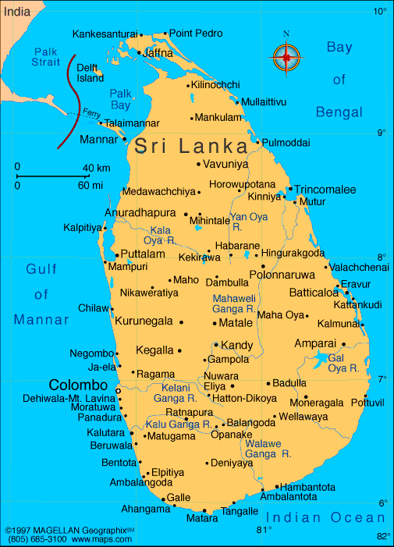

**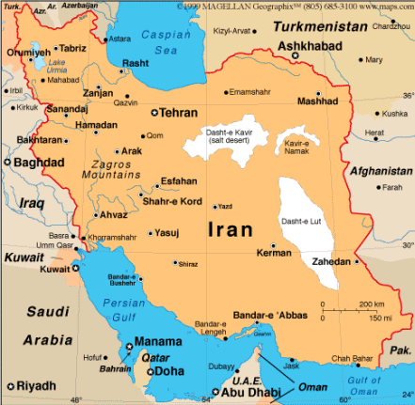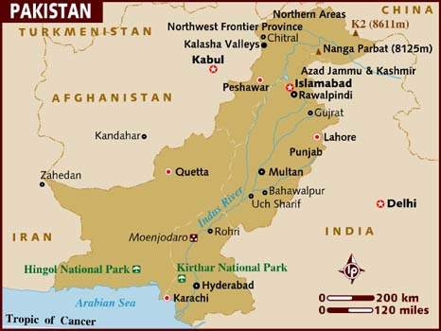Pakistan**

**IranIraq**

**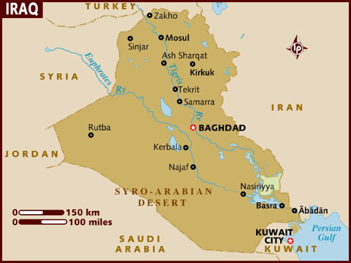**

**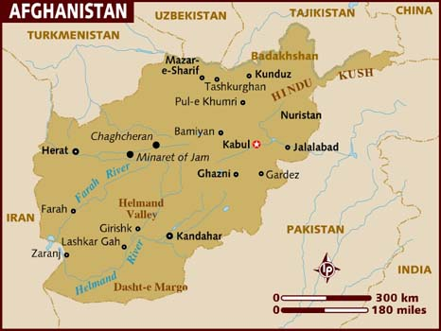Afghanistan**

**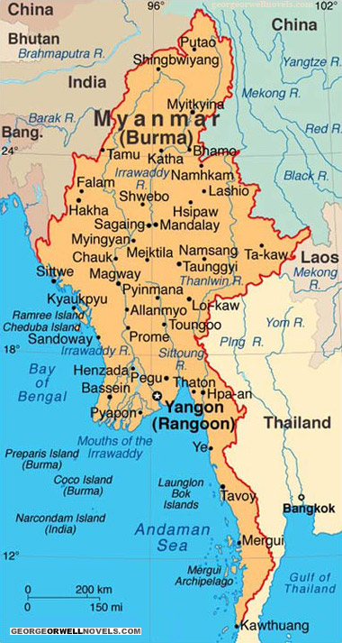Myanmar**

**The World**

**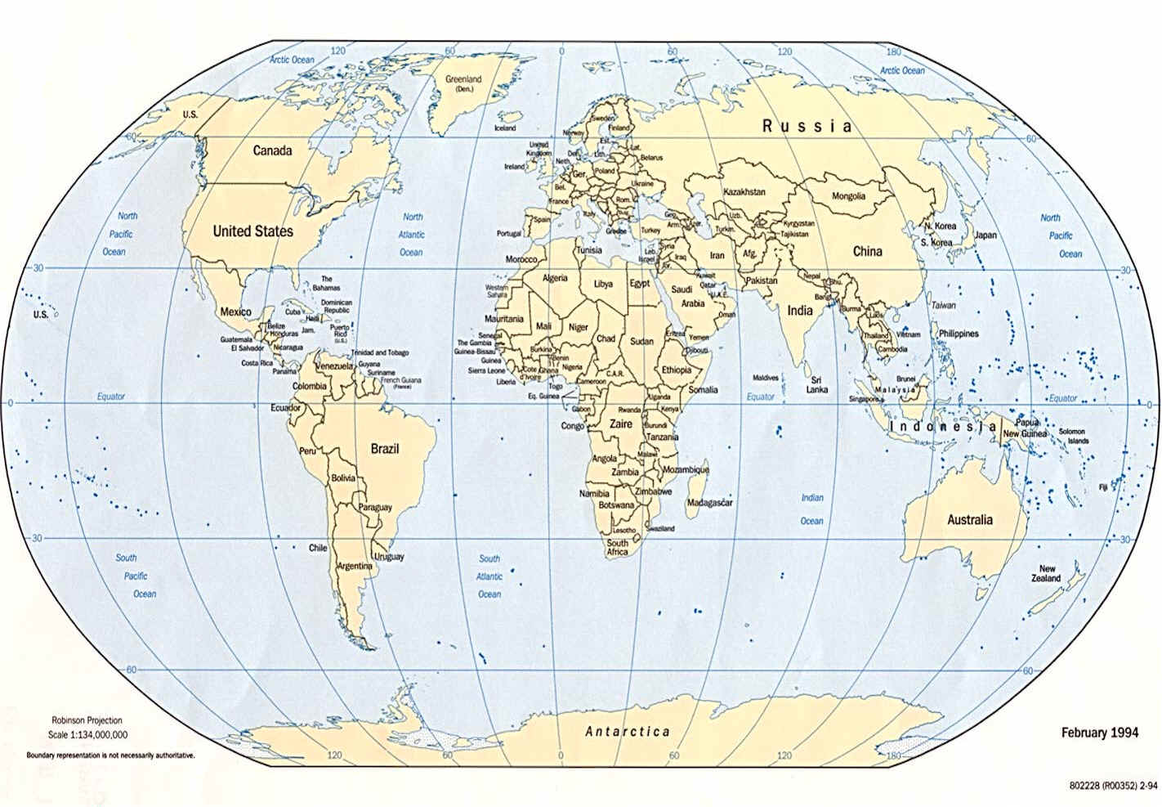**

**Map of Australia**

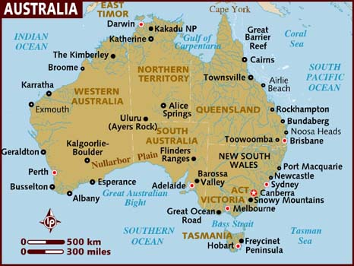

|  |  |  |  |  |  |  |  |
| --- | --- | --- | --- | --- | --- | --- | --- |
| **Time** | **Monday** | **Tuesday** | **Wednesday** | **Thursday** | **Friday** | **Saturday** | **Sunday** |
| **Morning** |  |  |  |  |  |  |  |
| **Afternoon** |  |  |  |  |  |  |  |
| **Evening** |  |  |  |  |  |  |  |

**Weekly Time Table**

****

**4. About Our Work**

**Resources**

# office-cleaner-sq-300x278.jpgkitchen hand.jpeg

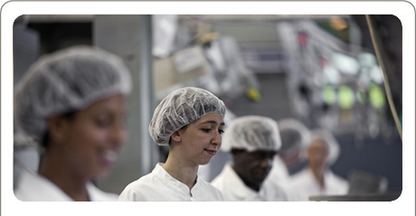1. Cleaner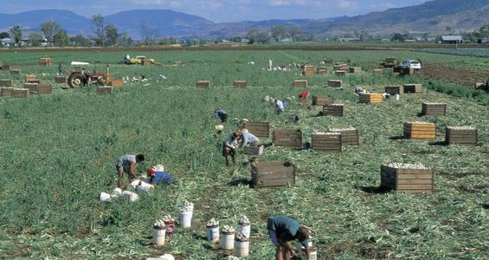 2. Kitchen Hand



3. Process Worker/Factory Hand 4. Car Detailer

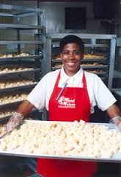

5. Picker 6. Food Attendant 1. What previous experience do you have?

*(I have worked as a ………….. list your skills)*

2. What hours can you work?

*(I can work day/evening and weekends)*

2. Can you do shift work?

*(Yes I can work days/evenings and weekends).*

3 Do you have a driver’s license?

*Yes…I used to drive…….*

*No…But I am near public transport.*

5. How is your English?

*My English is improving and I always ask if I don’t understand something.*

6. What is your work status? What visa are you on?

*I am on a ……… visa hoping to stay in Australia for a long time.*

7. What transport do you use?

*I am close to bus and train.*

8. Do you have any health problems?

*No. I had to have the medical when I came and I am fit and healthy. Yes I have\_\_\_\_\_\_\_ but it won’t affect my work.*

9. When can you start?

*I can start….(immediately, in 2 weeks…)*

Telephone:

A: Hello. My name is\_\_\_\_\_\_\_\_\_\_\_\_\_\_\_\_\_\_. I am calling about the \_\_\_\_\_\_\_\_\_\_\_\_\_\_\_\_\_\_ position advertised in \_\_\_\_\_\_\_\_\_\_\_\_\_\_\_\_\_\_\_\_\_\_\_.

Telephone:

A: Hello. My name is\_\_\_\_\_\_\_\_\_\_\_\_\_\_\_\_\_\_. I am calling about the \_\_\_\_\_\_\_\_\_\_\_\_\_\_\_\_\_\_ position advertised in \_\_\_\_\_\_\_\_\_\_\_\_\_\_\_\_\_\_\_\_\_\_\_.

Telephone:

A: Hello. My name is\_\_\_\_\_\_\_\_\_\_\_\_\_\_\_\_\_\_. I am calling about the \_\_\_\_\_\_\_\_\_\_\_\_\_\_\_\_\_\_ position advertised in \_\_\_\_\_\_\_\_\_\_\_\_\_\_\_\_\_\_\_\_\_\_\_.

Telephone:

A: Hello. My name is\_\_\_\_\_\_\_\_\_\_\_\_\_\_\_\_\_\_. I am calling about the \_\_\_\_\_\_\_\_\_\_\_\_\_\_\_\_\_\_ position advertised in \_\_\_\_\_\_\_\_\_\_\_\_\_\_\_\_\_\_\_\_\_\_\_.

Food attendant

Cleaner

Process Worker/

Factory Hand

Car Detailer

Kitchen Hand

Picker

Food attendant

Cleaner

Process Worker/

Factory Hand

Car Detailer

Kitchen Hand

Picker

Food attendant

Cleaner

Process Worker/

Factory Hand

Car Detailer

Kitchen Hand

Picker

Food attendant

Cleaner

Process Worker/

Factory Hand

Car Detailer

Kitchen Hand

Picker

**Name:**

**Address:**

**Mobile:**

**Email:**

**\_\_\_\_\_\_\_\_\_\_\_\_\_\_\_\_\_\_\_\_\_\_\_\_\_\_\_\_\_\_\_\_\_\_\_\_\_\_\_\_\_\_\_\_\_\_\_\_\_\_\_\_\_**

**Career Objective**

To successfully gain employment within the cleaning (e.g. hospitality, meat, food processing) industry, that allows me to utilise my skills and abilities in this field.

**Skills Summary**

*(List skills relevant to the position)*

**Work related history**

(List work with duties included, most recent work first)

**Training/Qualifications**

*(List training and subjects covered if relevant to the job)*

**Referees**

(try to keep the resume to one page – the most 2 pages)



**5. About our Accommodation**

**Resources**

**Types of Accommodation**

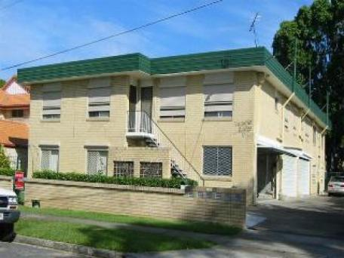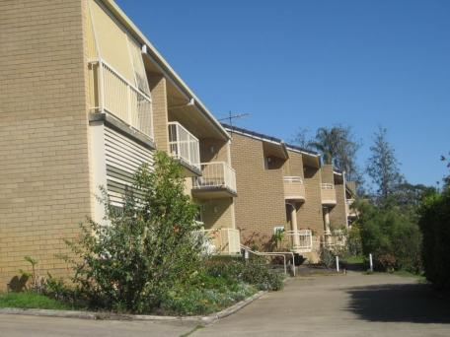

1. Apartments (brick) 2. Units (brick)

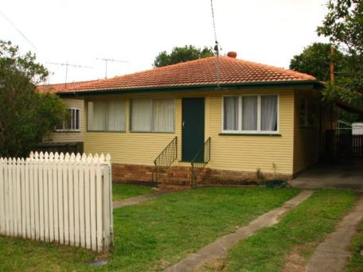

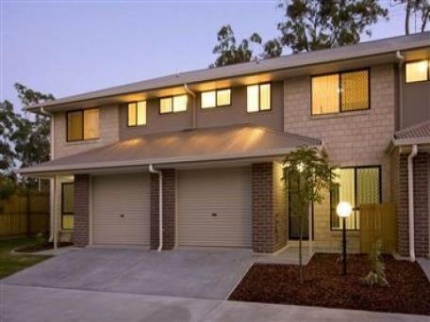

3. Town House (brick) 4. House (timber/weatherboard)

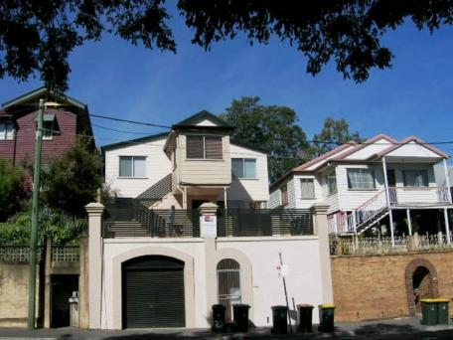

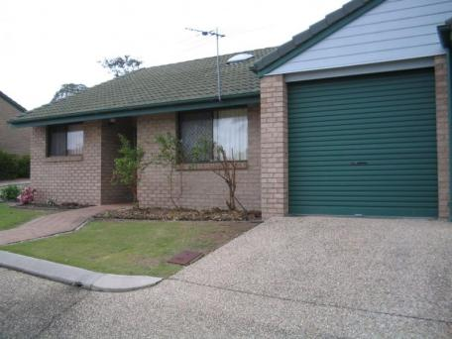

Shared accom,

5. Shared accommodation 6. Brick house

**Rooms in a Typical House/Unit**

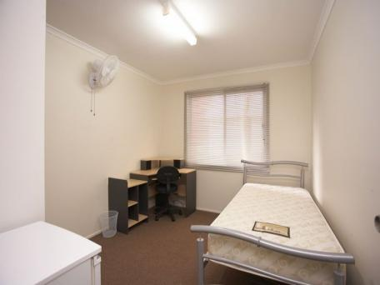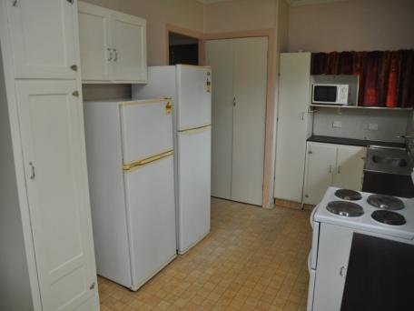

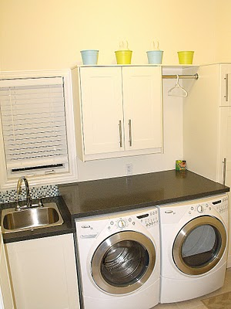1. Kitchen 2. Bedroom

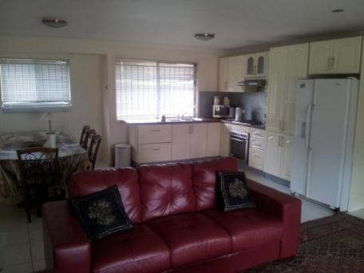

4. Lounge and dining room

3. Laundry

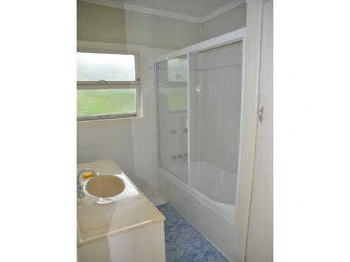

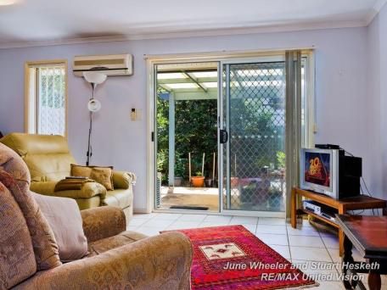

5. Lounge room

6. Bathroom



**5. About our Food**

**Resources**

**C:\Users\Salecich\AppData\Local\Microsoft\Windows\Temporary Internet Files\Content.IE5\RN58APN8\MC900015896[1].wmf AUSSIE FOOD**

[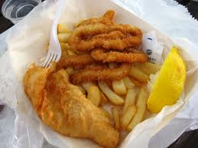](http://www.google.com.au/imgres?q=australian+food&hl=en&sa=X&rlz=1W1ACGW_enAU395AU395&biw=1600&bih=708&tbm=isch&prmd=imvns&tbnid=eiULJ0gEmHygeM:&imgrefurl=http://confinednomad.wordpress.com/tag/australia/&docid=cHiaDT5RPUvobM&imgurl=http://confinednomad.files.wordpress.com/2008/09/fish_chips.jpg&w=1080&h=810&ei=eU1uUPqSFaaiiAf34IHgBw&zoom=1&iact=hc&vpx=534&vpy=357&dur=7930&hovh=194&hovw=259&tx=182&ty=139&sig=112177847360625187305&page=2&tbnh=165&tbnw=220&start=22&ndsp=28&ved=1t:429,r:9,s:22,i:239) 

**Fish and chips Chicken and vegetable pie**

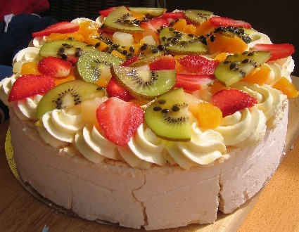 [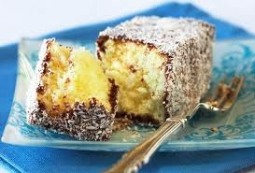](http://www.google.com.au/imgres?q=lamingtons&hl=en&sa=X&rlz=1W1ACGW_enAU395AU395&biw=1600&bih=708&tbm=isch&prmd=imvnse&tbnid=bL4i2FVvZ8F9yM:&imgrefurl=http://www.bakers-corner.com.au/cakes/chocolate-caramel-lamingtons/&docid=cDHf6NIk2XSliM&imgurl=http://www.bakers-corner.com.au/wp-content/uploads/2011/01/Chocolate_Caramel_Lamingtons_W1401100804.jpg&w=516&h=350&ei=XE9uUKbPAoSQiAfJ7oGYAg&zoom=1&iact=hc&vpx=1142&vpy=202&dur=58&hovh=185&hovw=273&tx=140&ty=121&sig=112177847360625187305&page=2&tbnh=160&tbnw=207&start=21&ndsp=28&ved=1t:429,r:12,s:21,i:232)

**Pavlova Lamingtons**

[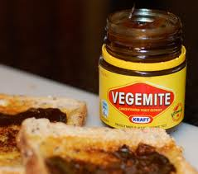](http://www.google.com.au/imgres?q=australian+food&hl=en&sa=X&rlz=1W1ACGW_enAU395AU395&biw=1600&bih=708&tbm=isch&prmd=imvns&tbnid=kbmxbvEHAxrTyM:&imgrefurl=http://www.gostudy.com.au/blog/food-in-australia/&docid=bFZaMBDOteiSQM&imgurl=http://www.gostudy.com.au/wp-content/uploads/2012/07/VegemiteDramagirl.jpeg&w=300&h=265&ei=7k1uUP3lFs-XiAeToIFw&zoom=1) [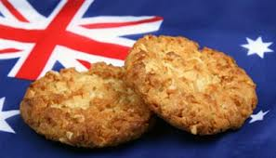](http://www.google.com.au/imgres?q=anzac+biscuits&um=1&hl=en&sa=N&rlz=1R2ACGW_enAU395&biw=1600&bih=708&tbm=isch&tbnid=GPddEyacA7hhwM:&imgrefurl=http://www.lifestylefood.com.au/recipes/12432/anzac-biscuits&docid=1PvxL9Psn-po0M&imgurl=http://www.lifestylefood.com.au/content/cache/400x225/Recipes/Thumbnails/anzac_biscuit.jpg&w=394&h=225&ei=jU5uULmuMOeviQeIqYCYBA&zoom=1&iact=hc&vpx=977&vpy=171&dur=3598&hovh=170&hovw=297&tx=185&ty=126&sig=112177847360625187305&page=1&tbnh=117&tbnw=205&start=0&ndsp=21&ved=1t:429,r:4,s:0,i:83)

**Vegemite spread Anzac biscuits**

**ANZAC BISCUITS**

**dd01007_**

[](http://www.google.com.au/imgres?q=anzac+biscuits&um=1&hl=en&sa=N&rlz=1R2ACGW_enAU395&biw=1600&bih=708&tbm=isch&tbnid=GPddEyacA7hhwM:&imgrefurl=http://www.lifestylefood.com.au/recipes/12432/anzac-biscuits&docid=1PvxL9Psn-po0M&imgurl=http://www.lifestylefood.com.au/content/cache/400x225/Recipes/Thumbnails/anzac_biscuit.jpg&w=394&h=225&ei=jU5uULmuMOeviQeIqYCYBA&zoom=1&iact=hc&vpx=977&vpy=171&dur=3598&hovh=170&hovw=297&tx=185&ty=126&sig=112177847360625187305&page=1&tbnh=117&tbnw=205&start=0&ndsp=21&ved=1t:429,r:4,s:0,i:83)

**INGREDIENTS:**

1 cup rolled oats

1 cup sugar

1 cup plain flour

¾ cup coconut

1½ teaspoons bicarbonate of soda

2 tablespoons boiling water

125g butter (or margarine)

1 tablespoon golden syrup

**METHOD:**

1. Preheat oven to 1700C.
2. Line biscuit trays with baking paper.
3. Combine rolled oats, sugar, sifted flour, and coconut.
4. Combine butter and golden syrup, stirring over a gentle heat (on stovetop) until melted.
5. Mix soda with boiling water, then add to melted butter mixture.
6. Stir butter mixture into dry ingredients.
7. Spoon dessertspoons of mixture on to prepared biscuit trays, allowing room for spreading.
8. Bake in slow oven about 20 minutes.
9. Cool on trays.

Makes approximately 3 dozen biscuits.

**ANZAC BISCUITS**

**dd01007_**

**[](http://www.google.com.au/imgres?q=anzac+biscuits&um=1&hl=en&sa=N&rlz=1R2ACGW_enAU395&biw=1600&bih=708&tbm=isch&tbnid=GPddEyacA7hhwM:&imgrefurl=http://www.lifestylefood.com.au/recipes/12432/anzac-biscuits&docid=1PvxL9Psn-po0M&imgurl=http://www.lifestylefood.com.au/content/cache/400x225/Recipes/Thumbnails/anzac_biscuit.jpg&w=394&h=225&ei=jU5uULmuMOeviQeIqYCYBA&zoom=1&iact=hc&vpx=977&vpy=171&dur=3598&hovh=170&hovw=297&tx=185&ty=126&sig=112177847360625187305&page=1&tbnh=117&tbnw=205&start=0&ndsp=21&ved=1t:429,r:4,s:0,i:83)**

**INGREDIENTS:**

1 cup rolled oats

1 cup sugar

1 cup plain flour

¾ cup coconut

1½ teaspoons bicarbonate of soda

2 tablespoons boiling water

125g butter (or margarine)

1 tablespoon golden syrup

**METHOD:**

1. Preheat oven to 1700C.
2. Line biscuit trays with baking paper.
3. Combine rolled oats, sugar, sifted flour, and coconut.
4. Combine butter and golden syrup, stirring over a gentle heat (on stovetop) until melted.
5. Mix soda with boiling water, then add to melted butter mixture.
6. Stir butter mixture into dry ingredients.
7. Spoon dessertspoons of mixture on to prepared biscuit trays, allowing room for spreading.
8. Bake in slow oven about 20 minutes.
9. Cool on trays.

Makes approximately 3 dozen biscuits.

**TASTY CHICKEN PIE**

**D:\PFiles\MSOffice\Clipart\standard\stddir2\dd01007_.wmf**

**INGREDIENTS:**

[](http://www.google.com.au/imgres?q=TASTY+CHICKEN+PIE&um=1&hl=en&sa=N&qscrl=1&rlz=1T4ACGW_enAU395AU398&biw=1600&bih=708&tbm=isch&tbnid=-xQM8oem-jSLdM:&imgrefurl=http://www.goodtoknow.co.uk/recipes/pictures/34380/how-to-make-shortcrust-pastry&docid=Du-UAyGWVaLv2M&imgurl=http://goodtoknow.media.ipcdigital.co.uk/111/000008ff9/173f_orh100000w614/Chicken-pie2.jpg&w=614&h=404&ei=yVVuUMHWAsWjiAf144CIBg&zoom=1&iact=hc&vpx=769&vpy=366&dur=3907&hovh=182&hovw=277&tx=136&ty=123&sig=112177847360625187305&page=2&tbnh=149&tbnw=199&start=21&ndsp=28&ved=1t:429,r:3,s:21,i:151)2 tablespoons butter

1 onion, chopped

1 celery stalk, chopped

1 carrot, diced

2 tablespoons flour

1 cup milk

1 teaspoon dried oregano

2 chicken stock cubes

2 cups diced, cooked chicken

310g can whole corn kernels, drained

2 sheets ready-rolled puff (or shortcrust) pastry

beaten egg to glaze (optional)

**METHOD:**

1. Heat the butter in a saucepan. Add the vegetables and cook for 2 minutes.
2. Stir in the flour and cook, stirring, for a further 1 minute. Stir in the milk, oregano and stock cubes. Bring to the boil, stirring, then simmer over a low heat for 2-3 minutes. Stir occasionally.
3. Remove from the heat and cool. When cold, stir in the chicken and corn.
4. Line a 20cm pie plate with one pastry sheet. Add the chicken mixture.
5. Moisten rim of the pastry, place the remaining pastry sheet over the top. Press the edges together to seal, then trim off the excess pastry. Crimp the edge and cut a slit in the centre of the pastry to allow the steam to escape.
6. Brush the pastry with beaten egg, if desired.
7. Bake in a preheated oven, 200oC, for 40-45 minutes, or until the pastry is golden brown and the filling is thoroughly reheated.
8. Stand for 5-10 minutes before serving.

**TASTY CHICKEN PIE**

**D:\PFiles\MSOffice\Clipart\standard\stddir2\dd01007_.wmf**

**INGREDIENTS:**

2 tablespoons butter

[](http://www.google.com.au/imgres?q=TASTY+CHICKEN+PIE&um=1&hl=en&sa=N&qscrl=1&rlz=1T4ACGW_enAU395AU398&biw=1600&bih=708&tbm=isch&tbnid=-xQM8oem-jSLdM:&imgrefurl=http://www.goodtoknow.co.uk/recipes/pictures/34380/how-to-make-shortcrust-pastry&docid=Du-UAyGWVaLv2M&imgurl=http://goodtoknow.media.ipcdigital.co.uk/111/000008ff9/173f_orh100000w614/Chicken-pie2.jpg&w=614&h=404&ei=yVVuUMHWAsWjiAf144CIBg&zoom=1&iact=hc&vpx=769&vpy=366&dur=3907&hovh=182&hovw=277&tx=136&ty=123&sig=112177847360625187305&page=2&tbnh=149&tbnw=199&start=21&ndsp=28&ved=1t:429,r:3,s:21,i:151)1 onion, chopped

1 celery stalk, chopped

1 carrot, diced

2 tablespoons flour

1 cup milk

1 teaspoon dried oregano

2 chicken stock cubes

2 cups diced, cooked chicken

310g can whole corn kernels, drained

2 sheets ready-rolled puff (or shortcrust) pastry

beaten egg to glaze (optional)

**METHOD:**

1. Heat the butter in a saucepan. Add the vegetables and cook for 2 minutes.
2. Stir in the flour and cook, stirring, for a further 1 minute. Stir in the milk, oregano and stock cubes. Bring to the boil, stirring, then simmer over a low heat for 2-3 minutes. Stir occasionally.
3. Remove from the heat and cool. When cold, stir in the chicken and corn.
4. Line a 20cm pie plate with one pastry sheet. Add the chicken mixture.
5. Moisten rim of the pastry, place the remaining pastry sheet over the top. Press the edges together to seal, then trim off the excess pastry. Crimp the edge and cut a slit in the centre of the pastry to allow the steam to escape.
6. Brush the pastry with beaten egg, if desired.
7. Bake in a preheated oven, 200oC, for 40-45 minutes, or until the pastry is golden brown and the filling is thoroughly reheated.
8. Stand for 5-10 minutes before serving.



**6. About Our Interests**

**Resources**

**Famous Footballers**

**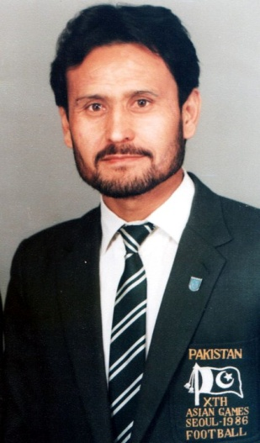**

Captain Zakir Hussain Muttiah Muralitharan (Sri Lanka)

(Hazara Afghanistan)





Abbas Aghaei – Iran Aatef Jenyat - Syria

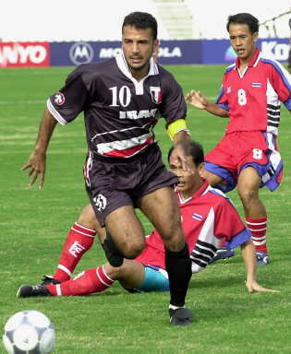

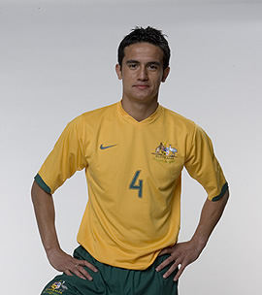 \

Tim Cahill – Australia Abbas Obeid Jassim – Iraq

**Hobbies and Interests**



Cricket Music

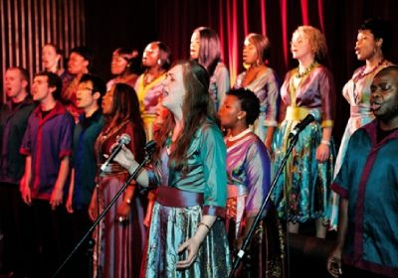

Art Singing

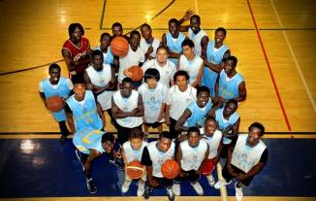

Basketball Movies

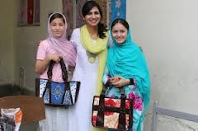

Soccer/football Craft/ handiwork/sewing

|  |  |  |  |  |  |  |  |
| --- | --- | --- | --- | --- | --- | --- | --- |
| **Time** | **Monday** | **Tuesday** | **Wednesday** | **Thursday** | **Friday** | **Saturday** | **Sunday** |
| **Morning** |  |  |  |  |  |  |  |
| **Afternoon** |  |  |  |  |  |  |  |
| **Evening** |  |  |  |  |  |  |  |

**Weekly Time Table**